NDIS SERVICE AGREEMENT
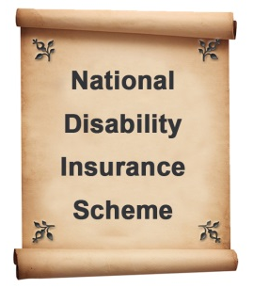 Who is making this agreement?

This Service Agreement is for _______________________________________________

and

xxxxxxxxxxxxxx Meals on Wheels
The Service Provider _______________________________________________

This Service Agreement will start on:

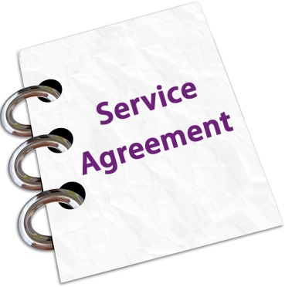 | - This agreement is made according to the rules and the goals of the National Disability Insurance Scheme (NDIS).

This Service Agreement will finish on:

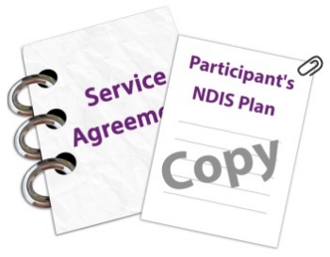 | - A copy of your NDIS plan is attached to this Agreement. (You don’t have to include your NDIS plan if you don’t want to)

What support will be provided?
- The Provider – Meals on Wheels agrees to provide you Meals on Wheels home delivered meals.
- Meals on Wheels meal package consists of Soup, Main Meal, Dessert and Juice
- Meals on Wheels will deliver the meals that you have ordered.

- The prices of the meal packages are listed in the Schedule of Supports
- The cost of the food itself is not covered by the NDIS and you will have to buy the food so that meals on wheels can prepare, cook, package and deliver the meal to you. The amount you have to pay to buy the food is listed in the Schedule of Supports
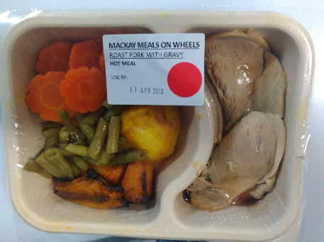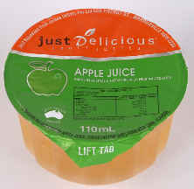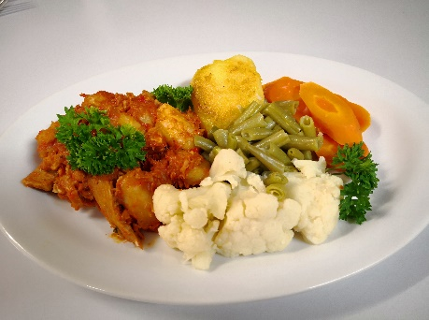
You must be at home to receive the delivered meal.
- Your delivery days are listed on the Schedule of Supports

How to pay for your meals?
There are different ways to pay for your meals.
- If you manage all of your NDIS funding yourself, you can pay for your meals directly to Meals on Wheels.
- If you have a plan nominee, they will pay Meals on Wheels for the preparation and delivery of meals.
- You will need to pay for the purchase of the food. The cost of the food is not covered by the NDIS.

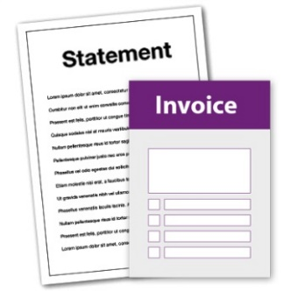 | - Meals on Wheels will provide you with invoices and statements for your meals after we have delivered the meals.
- You can pay for your purchase of food by electronic transfer, cash or cheque.
- You can pay daily, weekly, fortnightly or monthly. (Strike out which ever does not apply)

Your responsibilities:

- You need to tell Meals on Wheels about the meals you want delivered

- You need to ring Meals on Wheels the day before the scheduled meal delivery if you are not able to be at home to accept delivery of the meal.
- You need to ring Meals on Wheels the day before if you want to cancel your meals delivery.
- If you don’t ring, you will be charged for your meal and delivery.
 | - You need to tell Meals on Wheels if you want to finish receiving meals for a time or you want to end the Agreement.
 | - You need to let Meals on Wheels know if your NDIS Plan changes or if you stop using the NDIS.
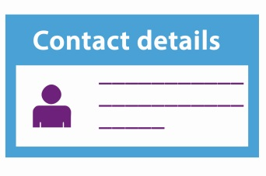 | - If you have a problem or need to talk to someone at Meals on Wheels you can ring on (phone number).
Also;
- treat the Provider and their staff with courtesy and respect
- give Meals on Wheels 30 days notice if you want to end the Service Agreement (see Ending this Service Agreement below for more information), and
- let Meals on Wheels know immediately if your NDIS plan is suspended or replaced by a new NDIS plan or you stop being a participant in the NDIS.
Responsibilities of Meals on Wheels

Meals on Wheels agrees to:

- Review the meals you want to receive regularly, with either you, or your nominated representative
- deliver meals that you have ordered
- deliver meals to meet your nutritional requirements
- deliver meals at the agreed delivery time

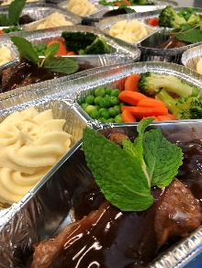 | - communicate openly and honestly in a timely manner  - treat you with courtesy and respect  - consult with you on decisions about what meals are provided  - Conduct an annual review
- give you information about managing any complaints or disagreements and details of Meals on Wheels cancellation policy
- listen to your feedback and resolve problems quickly
- give you a minimum of 24 hours’ notice if the Meals on Wheels has to change a scheduled meal delivery time
- give you the required notice if Meals on Whels needs to end the Service Agreement (see ‘Ending this Service Agreement’ below for more information)
- protect your privacy and confidential information
- provide delivered meals in a manner consistent with all relevant laws, including Meals on Wheels Nutritional Guidelines © 2012, the National Disability Insurance Scheme Act 2013 and rules, and the Australian Consumer Law;
- keep accurate records on the meals provided to you , and
- issue regular invoices and statements of the meals delivered to you.

Your contact details
Your daytime phone number:
Your evening phone number:
Your mobile number:
Your email address:
Your home address:
The name of someone we can contact if we can't get in touch with you:
Their phone number:

The service provider's contact details
Daytime phone number:
Evening phone number:
Mobile number:
Email address:
Business address:

Signatures
By signing this Agreement, you agree to all of the information included.
Participant name:
Signature:
Date:
Meals on Wheels Service provider name:
Signature:
Date:

Checklist for Service Agreements
I know who is making the Agreement.
This might be me and my service provider, or it might be my trusted person and my service provider.
I know what supports to include - Meals.
I know what is expected of me.
I know what is expected of my service provider.
I know how the supports will be paid for.
I know what to do if I want to make changes.
I know what to do if I want to end the Agreement.
I know what to do if I have a problem and I know who to contact.
I have written my Service Agreement, or I have worked with my provider to write the Agreement.
I have signed the Agreement.
I have attached my NDIS Plan to the Agreement if I want to.
I have kept a copy of the Agreement for my records.

Where can I get more information?
If you want more information you can visit one of the NDIS offices in person

You can phone NDIS:
1800 800 110
Or go to www.ndis.gov.au

Attachment – Schedule of Support

Activity of Support | Support Item Reference Number | NDIS funded meal price | Co-payment for the cost of food (the cost of raw food ingredient is not covered by the NDIS) | How the meals will be provided (list frequency and quantity of delivery)
Preparation and delivery of meals | 01_022_0120_1_1 | $11.61 per meal package | $4.00 per meal package | -Meal package will be delivered three times per week – Monday, Wednesday and Friday  Meal package includes soup, main meal, dessert and juice.  -Total meal packages delivered during term of this Service Agreement will be 131 Meals  -Total to be billed to the NDIA and payable under the Participant’s NDIS package will be $1520.91  -Total to be billed to Participant and payable by the Participant is $524

