

Workplace Bullying Training


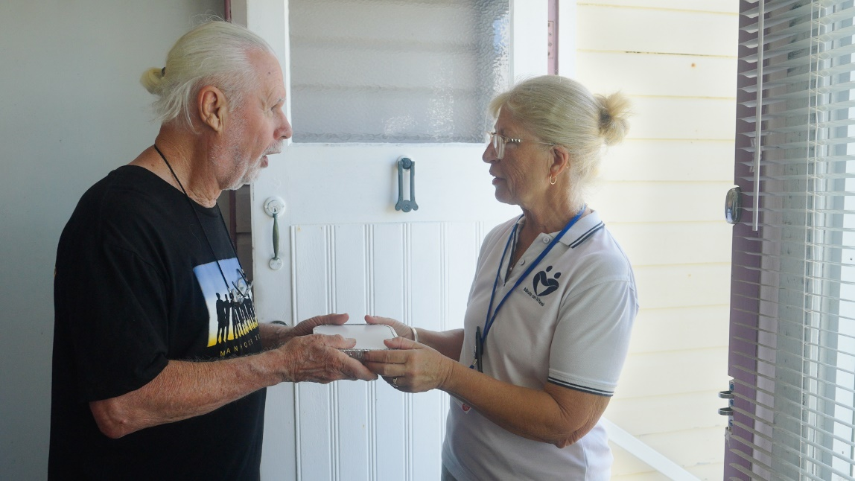

Based on the Meals on Wheels Allara Learning Workplace Bullying Module

Introduction
Thank you for choosing to volunteer with Meals on Wheels! We love welcoming volunteers to the Meals on Wheels family and we hope that you enjoy helping us to make a difference in the community.

Before you start assisting at Meals on Wheels, there are a few key things you need to know to protect yourself, your peers, and our clients.

Following these processes and your Service’s instructions will help you, others and our clients to stay safe. Enjoy your role in the Meals on Wheels family!



Workplace Bullying
Did you know that two-thirds of Australians experience workplace bullying? Bullying at work is a lot more common than we think!
Incidents involving bullying can greatly affect employees’ productivity and mental health. This is a workplace hazard, and we can address it better by treating it as a safety issue.
Bullying is a behaviour directed towards a person or group of people that is:
- Repeated: the behaviour occurs more than once.
- Unreasonable: a reasonable person would consider the behaviour to be inappropriate, victimising, humiliating, intimidating or threatening.
- Harmful: the behaviour is a risk to someone’s physical or mental health and safety.
Intent is irrelevant when it comes to bullying. Whether or not the bully tried to harm the victim, they must address and stop their behaviour.
Unreasonable behaviour includes:
- Acting aggressively or frightening others.
- Swearing, shouting and threats of violence.
- Spreading false rumours.
- Criticising, humiliating, slandering, undermining, gossiping about or making unreasonable demands of someone.
- Being rude, belittling, or making sarcastic comments to someone.
- Making abusive or intimidating phone calls, emails, notes, etc.
- Baiting or teasing someone.
- Playing nasty pranks or practical jokes on someone.
- Deliberately excluding someone from work discussions, communications, or activities.
- Knowingly ignoring someone.
- Withholding necessary information or holding up a workflow to stop someone from performing their duties.
- Reducing someone’s responsibilities or shifts for no reason.

Bullying is not:
- Expressing differences in opinion respectfully.
- Lodging a complaint about a manager or other employee’s conduct, if the complaint follows the correct procedure and is made in good faith.
- A one-off incident which is minor (e.g. losing your temper, shouting or swearing).
- Making objective or constructive comments on an employee or colleague’s performance, with the aim of helping them to improve.
- Applying rigid rules or procedures consistently.
- Managing performance reasonably.
- Deciding not to promote an employee based on a fair and transparent process.
- Taking disciplinary action, including suspension or termination when appropriate or justified based on the circumstances.
What to do if you’re being bullied
Sometimes people are not aware that their behaviour is bullying. Approach the person or group doing the bullying and ask to speak to them about the situation. Ask them to stop.
If that doesn’t work, or you feel intimidated or unsafe approaching them, speak to your manager, HR representative or access an Employee Assistance Program.
Your workplace should not tolerate bullying under any circumstances. Perpetrators of bullying can be criminally liable, and the victim can potentially sue them. They may also face disciplinary action, including losing their job.
According to the Fair Work Act (2009), it’s illegal to retaliate against someone who’s made a complaint or raised an issue about workplace bullying. This is called adverse action and includes:
- Dismissing an employee.
- Injuring the employee in their employment.
- Changing the employee’s position to the employee’s prejudice.
- Discriminating between the employee who made a complaint and the other employees.

Questions
Question 1
An otherwise pleasant colleague openly invites a few close work friends to their son’s birthday party. They don’t invite you. Is this workplace bullying?
- Yes
- No
Question 2
A co-worker always gets up and leaves the room when you enter, often making a scene about it. Is this workplace bullying?
- Yes
- No
Question 3
Your manager meets with you to discuss your colleagues’ concerns over your personal hygiene. It seems someone has complained that you have a strong odour. Is this workplace bullying?
- Yes
- No
Question 4
Your manager keeps criticising your performance in emails to you and your colleagues. Is this workplace bullying?
- Yes
- No

Answers
Question 1
No

Question 2
Yes

Question 3
No

Question 4
Yes

Acknowledgment of Workplace Bullying Training Completion

I herby declare that I have completed the Workplace Bullying Training and understand the information outlined.

Date ...................................................

Signature .........................................................

Supervisor ......................................................

Signature ........................................................

