

Workplace Health & Safety Training

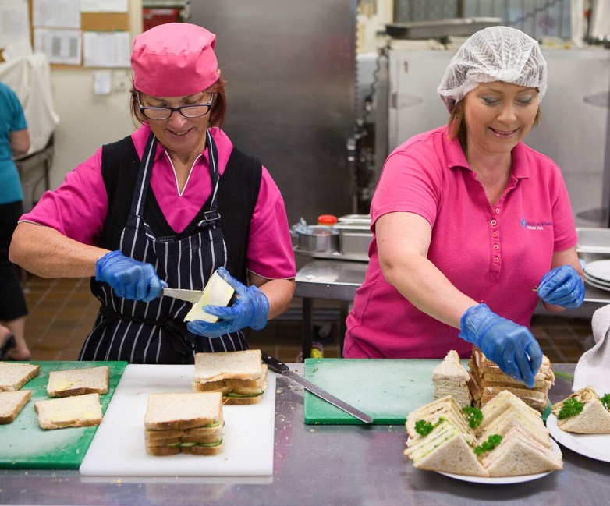
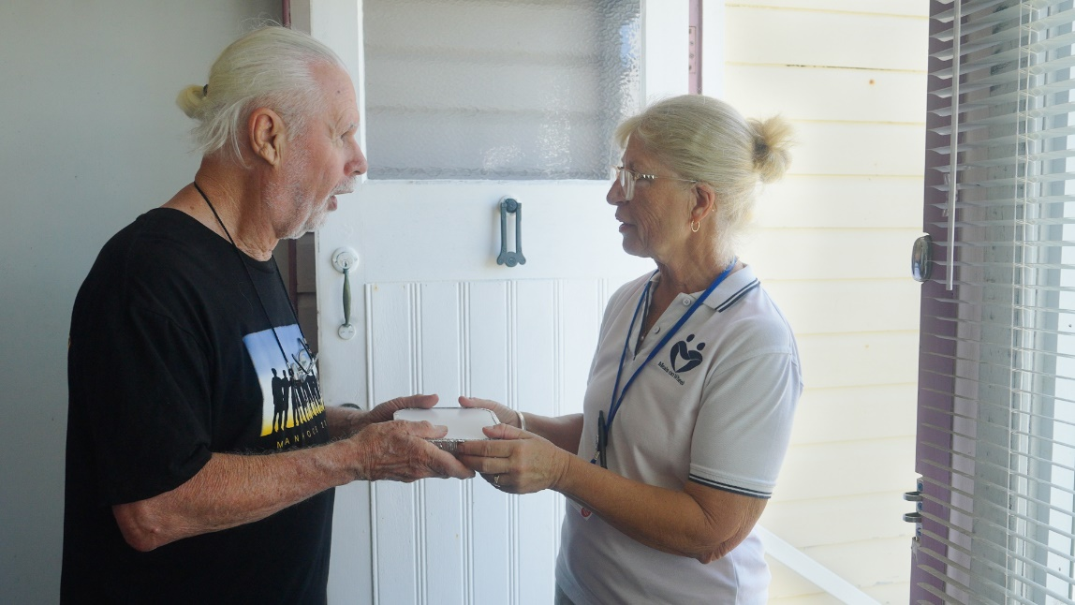

Based on the Meals on Wheels Allara Learning Workplace Health and Safety Module

Introduction
Thank you for choosing to volunteer with Meals on Wheels! We love welcoming volunteers to the Meals on Wheels family and we hope that you enjoy helping us to make a difference in the community.

Before you start assisting at Meals on Wheels, there are a few key things you need to know to protect yourself, your peers, and our clients.

Following these processes and your Service’s instructions will help you, others and our clients to stay safe. Enjoy your role in the Meals on Wheels family!

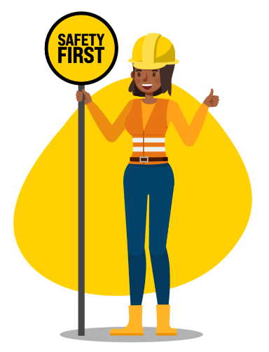

Workplace Health and Safety
Workplace health and safety (WHS) is all about looking after everyone’s health and safety in the workplace. Not only employees, but volunteers, customers, visitors and suppliers. The goal is to identify and manage potential risks so that everyone stays safe.
In Australia, there is legislation that regulates health and safety regulations and codes of practice.
Employers must protect health and safety by:
- Eliminating risks as far as is reasonably practicable.
- Reducing risks as far as is reasonably practicable, if they can’t eliminate them.
Volunteers and employees have a duty to look after their own health and safety and the health and safety of those around them. Their duties include:
- Proper behaviour at the workplace. They must not engage in behaviour that could harm someone, including taking shortcuts that increase risk.
- Cooperation. They must cooperate with the organisation by completing all mandatory training, following instructions, complying with policies and procedures and wearing any required personal protective equipment (PPE).
- Reporting Hazards. If they identify a hazard, they must report it, along with near misses and actual incidents, no matter how small.
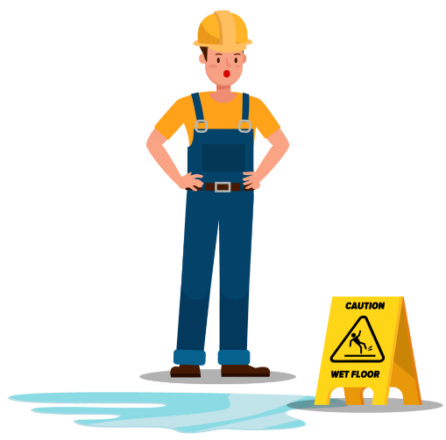
Health and safety is everyone’s responsibility!
A hazard is anything that could threaten the health, safety or welfare of anyone in a workplace. A key step to managing WHS is to identify potential hazards.
Once a hazard has been identified, it can be assessed and the risk managed using control measures.
If you notice a hazard, always report it. Check with your supervisor about the reporting process.

Examples of hazards include:
- Empty first aid kits.
- Spills. If you don’t know what caused the spill, isolate the area and report it to your supervisor straight away.
- Trip hazards. Wearing appropriate footwear for the task you are doing will reduce the risk of trips.
- Poor signage.
- Flickering lights. This can cause eye strain and also increase the chance of slips and falls due to poor visibility.
- Gas leak.
Psychosocial hazards are anything that could cause psychological harm (harm someone’s mental health). Below are some common psychosocial hazards:

Job demands
Traumatic events or materials

Remote or isolated work
Poor physical environment

Violence and aggression
Bullying

Harassment, including sexual harassment
Conflict or poor workplace relationship and interactions

Psychosocial hazards can cause severe stress, resulting in psychological or physical harm. Stress itself is not an injury, but is stressed often, over a long time, or to a high degree, it can be very harmful.

Psychological harm includes anxiety, depression, post-traumatic stress disorder and sleep disorders.

Physical harm includes musculoskeletal injuries, chronic disease or fatigue-related injuries.

If you notice a psychosocial hazard, speak to your supervisor, the HR department or follow the appropriate procedure to report it. You can also seek support from any available employee assistance program (EAP).

The main purpose of WHS is to prevent accidents. To decrease the likelihood of accidents, follow your supervisor’s instructions, safety signs and WHS procedures, and act in a safe and responsible manner at all times.

If an accident occurs, report it to your supervisor immediately or follow your organisation’s reporting process.

To reduce the likelihood of accidents:

Pay attention to warning signs.

Wear PPE.

Handle objects safely. Follow correct manual handling procedures.

Wash your hands to prevent illness.

Follow drug and alcohol policies.

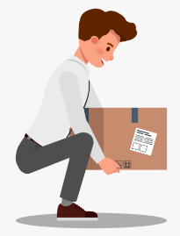
Manual handling training gives you the skills to safely handle objects, reducing risk of injury. The correct lifting position is to bend your knees and keep your back straight. Once you have lifted the object, keep your arms as straight as possible, keeping your elbows by your side.


Workplace emergencies may be rare, but they can and do happen. It’s important to be aware of your workplace’s emergency procedures so you can follow them when an emergency does happen.

It’s mandatory for your workplace to position emergency procedure diagrams in every building. These diagrams include floor plans which show the location of emergency exits and equipment, and maps for evacuation routes and emergency assembly areas.

In the case of an emergency, follow the instructions of your supervisor and your organisation’s emergency procedures.

Emergencies can include:

Fire

Explosions

Medical issues

Bomb threats

Threats of violence

Fire extinguishers come in different types and can be distinguished by a coloured band.

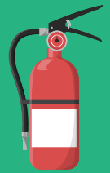
Type: Water

Colour: All Red

Suitable for: wood, paper, cloth, rubber, plastics, grass and coal

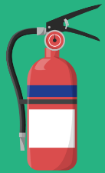
Type: Foam

Colour: Blue

Suitable for: petrol, kerosene, oil, tar, paint, wax, class A fires

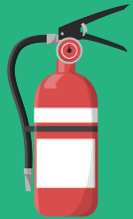
Type: Powder

Colour: White

Suitable for: electrical fires, class B fires

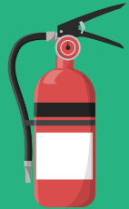
Type: Carbon dioxide

Colour: Black

Suitable for: electrical fires, class B fires

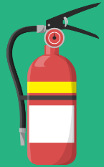
Type: Vaporising liquid

Colour: Yellow

Suitable for: electrical fires, class A and class B fires

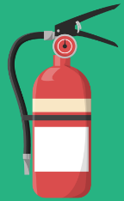
Type: Wet chemical

Colour: Oatmeal

Suitable for: wood, paper, cloth, rubber, plastics, grass and goal

To use a fire extinguisher effectively, use the PASS acronym:

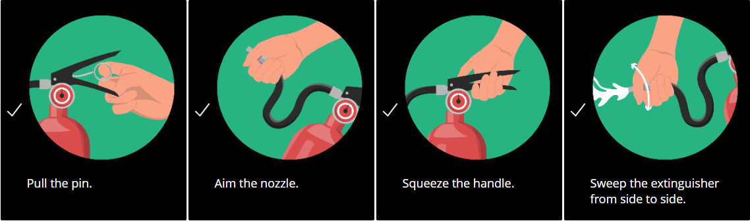

Questions
Question 1
A discoloured liquid has spilled onto the walkway and you don’t know what it is. What should you do?
- Cordon off the area and report it to your manager immediately.
- Clean up the spill immediately to stop someone from slipping and getting hurt.
- Let the spill dry out so nobody slips.
Question 2
You arrive at work in the morning and smell gas coming from the downstairs pipes. What should you do?
- Look for the pipe where you believe the leak is coming from.
- Turn off the gas supply to stop the leak.
- Notify your supervisor immediately.
Question 3
Your workplace must have which of the following signs?
- Entry and exit signs
- Fire safety and first aid signs
- Political and religious affiliation signs
- Danger and hazard signs
- Signs for company sponsors
Question 4
Which of the following do you think is classed as a workplace emergency?
- An individual threatening violence.
- A strange unattended bag.
- A contagious stomach bug that half the staff have caught.
- A robbery on the premises.
- A fire.

Answers
Question 1
A - Cordon off the area and report it to your manager immediately.
Question 2
C – Notify your supervisor immediately.
Question 3
A, B & D
Question 4
A, B, D & E

Acknowledgment of Workplace Health & Safety Training Completion

I herby declare that I have completed the Workplace Bullying Training and understand the information outlined.

Date ...................................................

Signature .........................................................

Supervisor ......................................................

Signature ........................................................

