

Texture Modified Diets

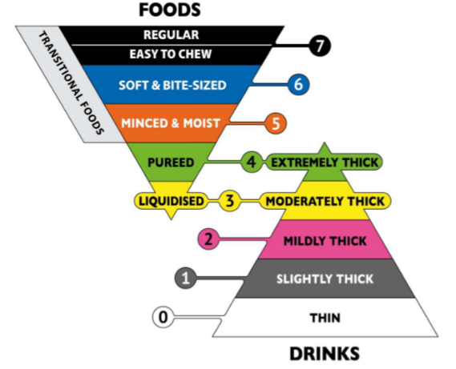

How to manage the needs of clients on texture modified diets

 Pureed (Level 4)
If a client is placed on a pureed diet by their speech pathologist, they require food that does not require biting/chewing to eat and can instead be brought to the back of the mouth using the tongue. This is usually due to individuals not being able to chew food, or who have reduced tongue control.
These clients will often suffer from pain and/or fatigue when chewing/swallowing, missing teeth, or poorly fitted dentures.
Food requirements:
Food suitable for a Level 4 Pureed Diet must:
- Be able to be eaten with a spoon (a fork may also be possible)
- Fall off a spoon in a single spoonful
- Not be able to be drunk from a cup – meaning it does not flow easily
- Not have lumps
- Not be sticky

Test to assess compliance:
Fork pressure test
- A fork can press into the pureed food and clear prong indentations are retained
- There should be no lumps and minimal granulation felt when pushing down
Fork drip test
- Sample of food sits on the fork with none, or only a small amount flowing through
- If it continuously drips or flows, then the food is not thick enough
Spoon tilt test
- The pureed food holds its shape on the spoon
- When tilted, the pureed food falls off the spoon in one lump
- Very little food should be left on the spoon. A thin layer that allows you to still see the spoon is acceptable, however, if a thick layer is present then it is does not meet IDDSI guidelines

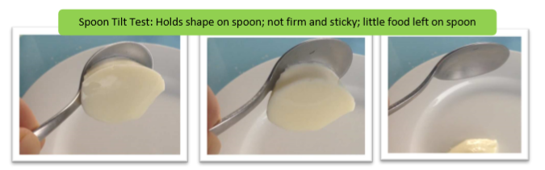
Examples and tips
Soup
- Add thickening agent or cornflour if too thin
- Blend soups so they have no lumps
- Add more vegetables and less water when making soups so that it becomes thick when blended
- Starchy veg like potato, pumpkin etc blend to a thick consistency
Mains
- Ensure meat is cooked until tender before blending. Some liquid may need to be added, however this should be minimal as it should remain thick
- Casseroles and stews can be blended – these are often more appealing to customers as they are have a similar appearance to standard casseroles and stews
- Potato, pumpkin, peas, and carrot puree easily
Desserts
- Custard, chocolate mousse and other milk-based desserts are often already suitable for pureed diets if they are prepared thick enough
- Add thickening agent or cornflour to thicken desserts and sauces

Menu Ideas:
- Pumpkin soup (thick)
- Potato & leek soup (thick)
- Carrot & sweet potato soup (thick)
- Beef stew (blended)
- Pureed apricot chicken, mash potato, pureed peas and pureed carrot
- Rice pudding (blended)
- Stewed fruits (blended)
- Baseless cheesecake (blended)


Minced & Moist (Level 5)
Minced & Moist diets are typically prescribed for clients who do not produce enough saliva and rely on their tongue to breakdown food. This makes food difficult to swallow and increases the likelihood of it getting stuck int their throat. Therefore, food must be moist and in small pieces. If a client is placed on a Minced & Moist diet by their speech pathologist, they require food that:
- Does not require biting
- Requires minimal chewing
These clients will often suffer from pain and/or fatigue when chewing/swallowing, missing teeth, or poorly fitted dentures.

Food requirements:
Food suitable for a Level 5 Minced & Moist Diets must:
- Be able to be eaten with a fork or spoon (chopsticks can be used in some instances)
- Have small lumps that are no larger than 4mm wide and 15mm long
- Allow lumps to be easily squashed with tongue force
- Not have separate liquid but is soft and moist

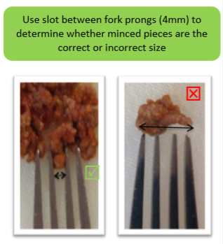
Test to assess compliance:
Fork pressure test
- The particles should easily separate when a fork is pressed into the food item
- A fork can easily mash the food without using excessive pressure (thumbnail should not turn white when pushing down)

Fork drip test
- Sample of food sits on the fork and does not easily fall though

Spoon tilt test
- The minced & moist food holds its shape on the spoon
- When tilted, the food should fall off the spoon easily
- Very little food should be left on the spoon. A thin layer that allows you to still see the spoon is acceptable, however, if a thick layer is present then it is does not meet IDDSI guidelines

Food Examples
Meat
- Finely minced or chopped (no larger than 4mm in width and 15mm in length)
- Served in mildly to extremely thick sauce
- Is tender and soft
Fruit & vegetables
- Finely minced, chopped or mashed
- Excess liquid is drained
- Serve with a mildly to extremely thick sauce
- Remove the skins or all fruit & vegetables
Grains & bread
- No dry bread
- No dry or crispy pasta
- No sticky or glutinous rice, couscous etc
- Rice and other grains should not separate into individual grains when cooked & served
- Serve with a mildly to extremely thick sauce

Foods to avoid (high risk foods)
- Large chunks of dry, tough meat
- Fibrous vegetables such as corn and carrot
- Nuts and undercooked legumes
- Soups that have large chunks
- Sticky cheeses eg camembert
- Bread based puddings
- Whole fruit & vegetables as well as their skins
- Crunchy foods e.g toast, dry biscuits, crisps
- Crumbly foods e.g bread crusts, pie crusts

Menu Ideas:
- Pumpkin soup (thick)
- Beef and vegetable soup (thick and small pieces of vegetables and beef)
- Shepherd’s pie (meat & vegetables are cooked until tender and no large pieces)
- Sweet and sour pork (well cooked rice, tender bite-size pieces of pork, thick sauce)
- Rice pudding
- Sponge cake with lots of thick custard

Note: Downgraded meals such as pureed appropriate menu items will also be suitable for those on a minced & moist diet, however, clients may not always enjoy receiving these.
Soft Diet (Level 6)
A Soft Diet is required for individuals who cannot safely bite off pieces of food, but are capable of chewing bite sized pieces and safely swallow them. If a client is placed on a soft diet by their speech pathologist, they require food that:
- Does not require a lot of biting/chewing to eat (minimises fatigue)
- Has small pieces to minimize choking risk
- Can be broken down with tongue force
These clients will often suffer from pain and/or fatigue when chewing/eating, missing teeth, or poorly fitted dentures.
Food requirements:
Food suitable for a Level 6 Soft Diet must be:
- Able to be mashed/broken down with pressure from a fork, spoon or chopsticks
- Soft, tender and moist but with no separate thin liquid
- Cut into bite sized pieces (1.5cm x 1.5cm pieces)
- Not require a knife to be cut

Test to assess compliance:
Fork Pressure Test (This test can also be done using a spoon)
- The side of a fork can cut/break apart the meal into small bite size pieces
- A fork can press into a sample piece (1.5cm x 1.5cm) resulting in the sample being squashed, broken, or altered even after the fork is removed. Note: If you need to apply high pressure (still pushing after your thumb nail turns white) when pushing the fork into the sample then it is not soft enough.

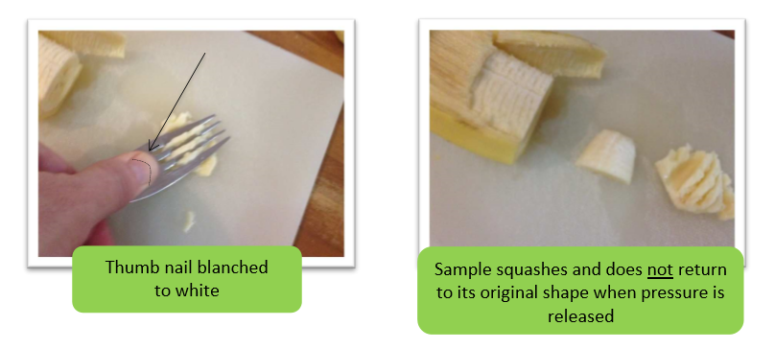
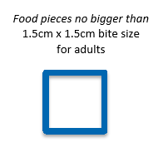
Food Examples
Meat:
- Tender meat in pieces of >1.5cm x 1.5cm
- Soft fish that easily breaks into small pieces
- Fish with no bones or tough skin
Stews/curries:
- Sauces/liquids must be thick
- Can have meat/vegetables if tender and in small pieces
- No big, hard lumps
Fruit:
- Serve minced/mashed if cannot be cut into bite size pieces
- Drain excess juice
- Avoid high liquid fruits such as watermelon
Vegetables
- Steamed/boiled vegetables cut into small pieces >1.5cm
- Stir fry vegetables are often too firm and therefore are unsuitable unless their softness is checked (fork pressure test)
Grains & bread:
- No dry bread of any kind e.g toast, sandwich
- No grainy rice or couscous
- No sticky rice or couscous
Desserts:
- No dry items such as sponge cakes (unless paired with custard or a thick sauce to soften)
- All pieces are >1.5cm
- Avoid nuts
Note: Downgraded meals such as minced and moist appropriate menu items will also be suitable for those on a soft diet, however, clients may not always enjoy receiving these.

Foods to avoid (high risk foods)
- Fibrous fruit & vegetables e.g pineapple, beans, celery
- Fruit & vegetable skins e.g peas, grapes, beans,
- Mixed consistencies e.g mince & thin gravy, soup with lumps
- Crunchy foods e.g toast, dry biscuits, crisps
- Crumbly foods e.g bread crusts, pie crusts

Menu Ideas:
- Shepherd’s pie (meat & vegetables are cooked until tender and no large pieces)
- Tender roast chicken with gravy & vegetables (bite size and soft)
- Fish pie (bite size pieces, tender fish and thick sauce)
- Sweet and sour pork (well cooked rice, tender pork and bite size pieces)
- Stews
- Rice pudding
- Crème caramel
- Stewed fruit & custard
- Sponge & custard

For more info on texture modified meals go to: https://ftp.iddsi.org/Documents/Complete_IDDSI_Framework_Final_31July2019.pdf

