

Harassment & Discrimination Training


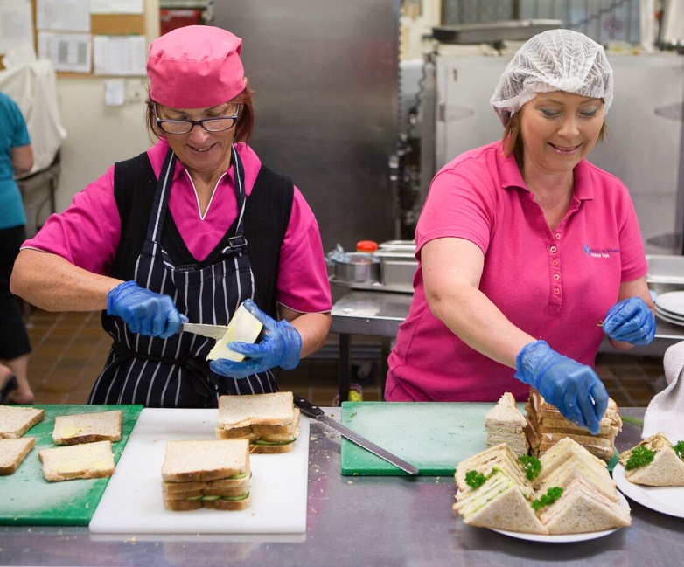


Based on the Meals on Wheels Allara Learning Harassment and Discrimination Module

Introduction
Thank you for choosing to volunteer with Meals on Wheels! We love welcoming volunteers to the Meals on Wheels family and we hope that you enjoy helping us to make a difference in the community.

Before you start assisting at Meals on Wheels, there are a few key things you need to know to protect yourself, your peers, and our clients. Everyone deserves to feel respected and included and it’s important to remember that bullying, harassment, discrimination and victimisation are not okay.

Following these processes and your Service’s instructions will help you, others and our clients to stay safe. Enjoy your role in the Meals on Wheels family!



Harassment and Discrimination
Sexual harassment and discrimination can take many forms and can happen to anyone in the workplace or even outside the workplace.
Sexual harassment is defined as someone doing something of a sexual nature that makes you feel uncomfortable, embarrassed or intimidated. This can be physical, verbal or even just showing someone images they don’t want to see.
Sexual harassment is illegal. Whether or not someone thinks what they are doing is a joke, if it makes you feel uncomfortable, it could be considered sexual harassment. It only takes one instance of inappropriate behaviour to be considered harassment.
Common forms of sexual harassment are:

Verbal: includes sexually suggestive comments or jokes, intrusive questions, repeated invitations for dates or requests or pressure for sex.
Sexually explicit photos: to send or ask for these pictures, posters or gifts is sexual harassment.
Intimidating behaviours: inappropriate staring or leering, sexual gestures, indecent exposure, or being followed, watched or someone loitering nearby.
Inappropriate physical contact: unwelcome touching, hugging, cornering or kissing, or actual or attempted rape or sexual assault.
Sexual harassment using technology: sending sexually explicit emails, SMS or communication through social media, indecent phone calls, repeated or inappropriate advances online, or sharing or threatening to share intimate images or film without consent.

Discrimination happens when someone or a group of people are treated unfairly because of things like their age, race or sexual orientation. This is called direct discrimination. It can also happen when a rule or policy seems fair but ends up hurting certain people because of things like their personal characteristics. This is called indirect discrimination.
Exclusion or preference because of a person’s inability to perform certain duties that are vital for a role is not considered discrimination.
In Australia, it is illegal to discriminate against a person or group based on a particular attribute, trait or characteristic, known as a protected attribute.
Protected attributes:
- Disability
- Pregnancy and breastfeeding
- Race
- Religious belief or activity
- Sex and gender
- Employment and industrial activity
- Marital, parental or carer status
- Sexual orientation
- Physical features
- Age
- Political belief or activity
- Personal association to someone with a protected attribute

Victimisation happens when someone is treated badly just because they either made a complaint about discrimination or sexual harassment, or because they’re thinking about making one. If someone has helped someone else make a complaint, they can be a victim of victimisation.
For example:

Threatening someone as a result of them reporting harassment or discrimination.
Denying a promoton that has been otherwise earned.
Changing a person’s shifts so their income is affected or they are unable to work.

Terminating employment.
Gossiping or spreading rumours about someone who reported harassment or discrimination.

What to do if you experience inappropriate behaviour
If you experience sexual harassment, discrimination, or victimisation, the first step to resolve the situation is to have a calm talk with the person causing the problem. Let them know how the behaviour is affecting you and ask them to stop.
If you feel too uncomfortable to do this, you can report the matter to the manager or via the organisation’s complaints or grievance procedure.
Informal processes can be more effective at resolving the issue early without the need for escalation. However, you may also have the option to lodge a formal complaint with an external body such as the FairWork Commission, the Australian Human Rights Commission or the Queensland Human Rights Commission.

To prevent discrimination, harassment and victimisation, everyone has a role to play.
Volunteers and employees can act in accordance with the organisation’s values, policies and code of conduct. They can ensure their behaviour towards everyone is safe and positive.
Managers should lead by example in their behaviour. This means ensuring the workforce receives education and training about inappropriate behaviours and how to deal with them if they do occur. Managers should also encourage the workers to take early action and report cases of harassment, discrimination and victimisation.

Questions
Scenario 1
John feels uncomfortable around his manager Kelly. He’s upset by how she behaves around him, but he’s not sure about how to approach the situation. John asks for your advice:
“Hey, can I talk to you about something? I know that everyone is friendly and we have a warm culture in the office, but Kelly is making me feel uncomfortable with her long and warm hugs. I asked her to stop last week but she just laughed it off. She also keeps emailing me and saying we should go out for dinner.”
What is your response?
- “she’s cute. What’s wrong with you?”
- “She’s only being friendly. Just ignore it.”
- “That’s sexual harassment, John.”
- “I can tell that, deep down, you really like it.”
John responds, “I’m glad you understand. I’ve already asked her twice to stop, but it keeps happening. I can’t ask her again. What should I do?”
What is your response?
- “Just ask her again and tell her how you feel.”
- “You should speak to HR about it.”
- “You should contact the Human Rights Commission.”
- “Honestly, I don’t think it’s a big deal.”

Scenario 2
Your coworker Betty has been working with your organisation for 17 years. She noticed recently that she is receiving fewer work hours.
Betty asks to speak with you. “It’s great to have new, young faces in the office, but I feel like my hours have been cut, as lately I’m only working one day per week. I used to work five days a week! What should I do?”
What is your response?
- “You’d be close to retirement age anyway!”
- “That’s discrimination! I’ll speak to the manager to find out what’s going on.”
- “You should be happy with one shift, if I’m honest.”
- “I’m sure it’s fine. Wait until there’s more work available.”
The manager responds, “Thanks for bringing your concerns about Betty to us. Her treatment by the company was completely unacceptable and we are reviewing our processes. What can we do to stop this from happening again?”
What is your response?
- “Only hire younger people from now on.”
- “Give older employees dull tasks to force them out.”
- “Some older employees need to be given management positions.”
- “Management needs to ensure that all staff are familiar with their legal obligations and the appropriate policy on discrimination.”

Scenario 3
Preston feels he’s being punished at work by his coworker Adam, who is in a more senior position.
Preston says to you, “Hey mate. Adam has been giving me a hard time lately and giving me heaps of extra tasks to complete. I think he found out I went with Nadia to HR about this inappropriate behaviour towards her and the other women in the office. He mentioned something about me being ‘friends with a rat’.”
What is your response?
- “So what? As long as it isn’t me, I don’t mind.”
- “He can’t do that to you! You’re being victimised.”
- “Hard time? It sounds like you’re scared of hard work.”
- “Adam said that? Are you sure it wasn’t a joke?”
Preston responds, “We can’t approach Adam. He’s the senior manager here and you’ve seen what he can do if we complain. What are our options?”
What is your response?
- “Maybe you should approach Adam?”
- “He must be joking around. Forget it.”
- You’re reading too much into this.”
- “You need to escalate this to the proper authorities.”

Acknowledgment of Harassment and Discrimination Training Completion

I herby declare that I have completed the Harassment and Discrimination Training and understand the information outlined.

Date ...................................................

Signature .........................................................

Supervisor ......................................................

Signature ........................................................

