

Food Transport Training
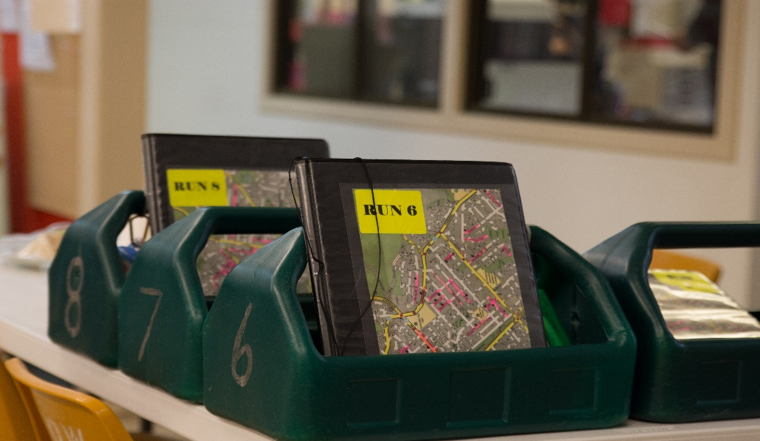
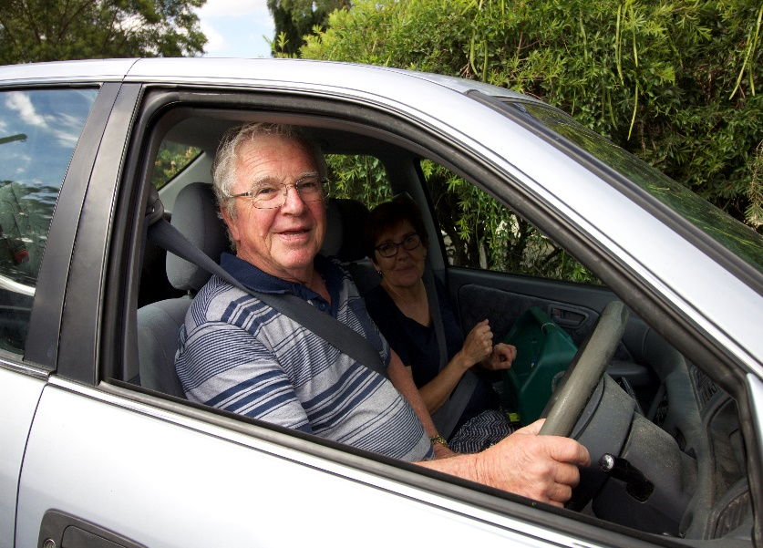
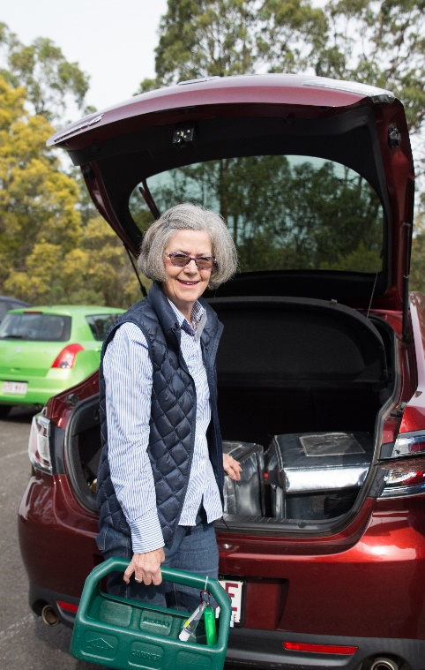

Based on the Meals on Wheels Allara Learning Food Transport module

Introduction
Thank you for choosing to volunteer with Meals on Wheels! We love welcoming volunteers to the Meals on Wheels family and we hope that you enjoy helping us to make a difference in the community.

Before you start delivering meals, there are a few key things you need to know. This includes knowing how to deliver meals safely and within temperature, avoid contamination and understanding what to do if a client doesn’t answer the door.

Whether you are a new volunteer or are doing this training to refresh your knowledge, we hope that you learn something that will help to keep yourself and our clients safe.

Following these processes and your Service’s instructions will help you, others and our clients to stay safe. Enjoy your role in the Meals on Wheels family!

When first arriving to the Service for your delivery run, make sure you let the right people know you are here and remember to sign in. When delivering you will likely be paired up with someone to ensure the safety of both yourself and the clients.
Before you get going, there are a couple of things you should know about the food we work with. Potentially Hazardous foods, the temperature danger zone and the 4 hour/2 hour rule are all things you will need to keep in mind when delivering.
Potentially Hazardous Foods, or PHF for short, are foods that might contain food-poisoning bacteria and can become unsafe to eat if not kept at the right temperature. PHF include raw and cooked meat, seafood, dairy products like milk and custard, cooked rice and pasta, eggs and any meals that contain these foods.
The temperature danger zone is the temperature where bacteria can grow quickly in PHF. The danger zone is between 5°C and 60°C. This means that hot foods must be kept above 60°C and chilled foods must be kept below 5°C.
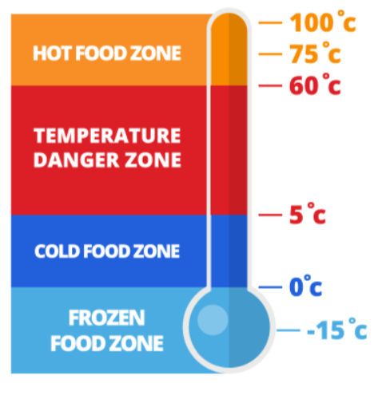

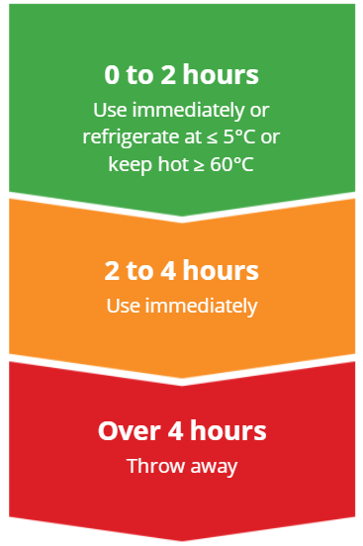
However, PHF can be held in the temperature danger zone for a short time, using the 4 hour/2 hour rule. If PHF have been in the danger zone for:
- less than 2 hour, the food can be returned to the correct temperature.
- between 2 and 4 hours, the food must be consumed in that time.
- over 4 hours, it must be discarded.
These three things are important because when we are delivering PHF, they could fall into the temperature danger zone, and that’s when the 4 hour/ 2 hour rule comes into play!
Contaminated food can make people sick or even cause death. This is especially so for certain groups of people called high risk groups. Many of our clients who are elderly fall into a high-risk group.
Now that we know a bit more about the importance of safe food transport, let’s get packing!
After you make sure the vehicle and storage bags are clean, the first thing you need to do is place eskies into the car. If they haven’t been checked already, check if the packed eskies you receive from the kitchen contain all that you need.
When checking, you should make sure that you have the correct meals for your delivery and that there are no spills or damaged packaging. The food we deliver needs to be packaged properly. If there is a spill or leak, there is a chance that dirt or bacteria could get into the food and cause contamination. Letting the kitchen know of any incorrect or damaged packaging means the meal can be replaced and the client can eat a safe meal.
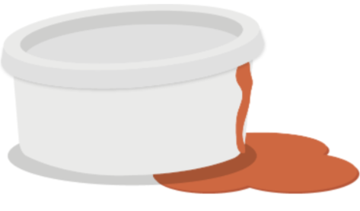

Now that you have checked the meals, you will need to pack them into the car.
Most Services will have already packed and checked the eskies but it is important that the meals be kept in the correct storage eskies. Packing food into the correct containers will keep the food out of the temperature danger zone for as long as possible. If food goes into the wrong container, every meal in the container could be at risk of falling into the temperature danger zone. The food will gather bacteria faster and could make our clients very sick if eaten.
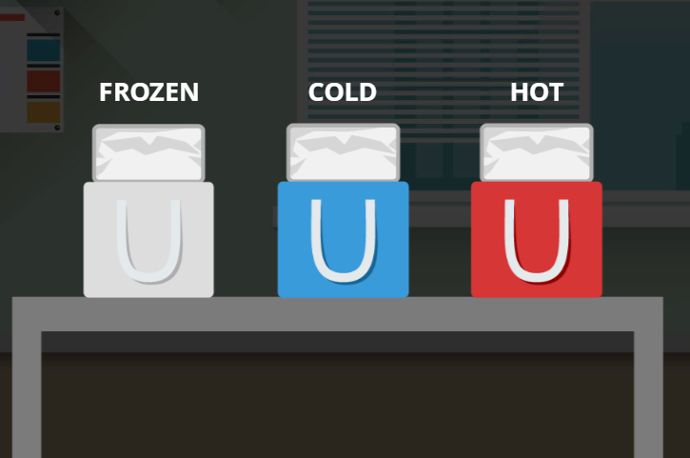

Now let’s get delivering!
For every delivery run you make, you will have a delivery list, showing the addresses of where you need to deliver meals, as well as what meals need to be delivered. It is always good to double check you have all the correct items. You should note the time that you leave the kitchen so you’re aware of how long you’re travelling with the food. There are also some general hygiene practices to keep in mind.
Our clients are vulnerable to illness and disease, so you need to stay away if you’re ill. If you’re feeling unwell before a shift, let Meals on Wheels know immediately so a replacement for your shift can be organised.
Preventing contamination is extremely important. It is also important to remember to wear clean clothes and to never eat, sneeze, cough, spit or smoke near meals.

Because you’re going to be around food, you need to make sure your hands are clean. To keep your hands clean you should:
1. Only wash your hands in provided basins.
2. Use soap to work up a lather.
3. Wash your palms, fingers, thumbs and fingernails.
4. Rinse off soap under hot water.
5. Dry your hands with paper towel.
Always wash your hands after using the toilet, eating or drinking, biting your nails, smoking, coughing, sneezing or coming into contact with animals. This helps prevent contaminating the food you are delivering. To keep your hands clean whilst delivering you may also wish to use hand sanitizer as this is easy to carry. Sanitizer should be used before and after every meal delivery you make to ensure your hands remain clean and germ free.
As a food handler, you need to ensure that you don’t touch any food you are delivering. This includes contact with your hair, saliva, fingernails, clothes or jewellery. If food comes into contact with anything like that, it will become contaminated and could cause an illness.
We are now going to make our first delivery!

When delivering, we need to check the run sheet and then pack our basket accordingly. It is best to place all meals in a delivery basket to avoid injuries like burns when taking them inside to a client. Take the meals from their correct storage container when you arrive at the client’s home to ensure temperature is maintained. Carrying meals in the basket whilst driving can increase the risk of contamination and injury. Hot meals and cold meals must be placed at opposite ends of the basket so they remain at the right temperatures.
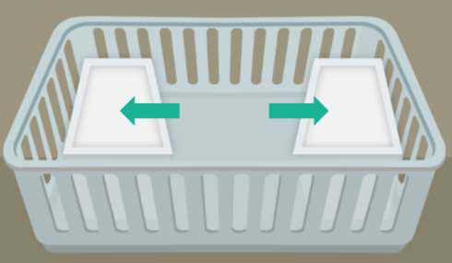

After every delivery you make, you need to tick off the delivery from the list. This allows us to make sure the food has been delivered to the client.

Now let’s go to our next address. This next delivery is a big one… 14 meals! If an esky is heavy, your delivery partner should help you carry it. This will reduce the chance of hurting yourself. Remember, always bend your knees and keep your back straight when lifting.
That delivery was the bulk of the meals today, so there are only a handful of meals left for this run. Whilst it might seem like a good idea to combine the remaining meals into one esky, the meals need to remain under correct temperature control, so should stay in their allocated esky.
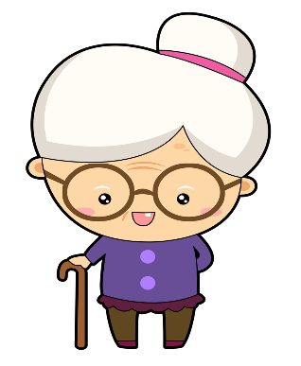
Our next delivery is to Meryl, an elderly lady who doesn’t manage to leave her home much these days but is lovely and always up for a chat. When you go to deliver the meal, the door is locked but you can hear her and it sounds like she is in pain. In this situation we need to follow our non-response procedure.
This Photo by Unknown Author is licensed under CC BY-NC
Non-response procedure:
When you try to make a delivery and no one answers you should call your Meals on Wheels Service immediately to notify them. The Service may the instruct you to:
- Check the premises and try to find out if anyone is there.
- Call an ambulance if you have identified the client is in distress or needs help.
- If the client is in distress do not move the person and no not enter the house unless able to safely do so.
If the client refuses assistance and you are still concerned, call the Meals on Wheels office and they will organise for the next of kin to visit the client. If the client is clearly in danger, refuses assistance and you feel that waiting to call the next of kin will further endanger the client, call the ambulance anyway. Paramedics are trained to assist clients who are unwilling to seek assistance.
If a client is does not answer, you can’t just leave the meal on the step or in an esky. Some clients may have an alternate plan for delivery of their meals such as requesting the meal be left with a neighbour. This will ensure that the meal will still be safe to eat. If no alternate plan is in place, you need to return the meal to the Service. Additionally, you may leave a card in the mail box to say you attempted to deliver and to contact the Service.

After the incident with Meryl, you are running behind schedule for the final deliveries. You need to deliver a hot meal to a client, but it has been about two hours since you left the Meals on Wheels kitchen.
Because it has been more than two hours, you should contact Meals on Wheels so they can organise an alternative and head back to return this meal to the kitchen. You need to be careful with delivery times; all hot meals must be delivered within two hours of leaving the kitchen.
Sometimes you will have a test meal to take on a delivery run. Meals on Wheels uses these test meals to check the temperatures of the food.

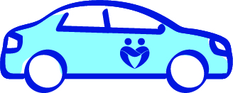

Now let’s get back to Meals on Wheels so we can return that last meal and finish up! Each time you return to Meals on Wheels, don’t forget to sign out and provide any client feedback. This can include client well-being and any issues or changes to the delivery order!
The next time you go on a delivery run, keep in mind all of the key things we have talked about.

Quiz
- When checking your meals before you leave the Service, you notice there could be a problem with some of the packaging. A bowl of soup has spilled out onto the side of the container because of a loose lid. What do you think we should do?
- Reseal the lid, clean the side of the container and pack it into the car.
- Don’t pack the soup and let the kitchen know there was a spill.

- You also notice the container for stew has a crack in the lid. What should you do?
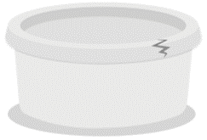
- Find a replacement lid yourself
- Make sure nothing is on top of the container in the car
- Don’t pack the stew and alert the kitchen

- The hot roast pack also has a hole in the foil container. What should you do?
a) Don’t pack the roast and alert the kitchen.
b) Wrap the container with foil and pack it in the car.

- Which esky should the following items go in?
• Quiche & salad
• Hot beef stew
• Frozen lasagna

- Ham and Salad
- Hot roast & veg
- Sandwiches

- It is great to see that you’re healthy and feeling well today. In the case that you’re not feeling well before a delivery, what should you do?
- Nothing. Complete the delivery as planned to ensure our clients receive their meals.
- Contact meals on wheels so they can organise a replacement driver for the day.

- Because you’re going to be around food, you need to make sure your hands are clean. What do you think the best way of keeping your hands clean is?
a) Apply soap, wash your hands, rinse and dry – or use sanitizer.
b) Scrub and rinse hands under water to remove visible dirt.

- The first client on your run is Mrs. Swimmer. You think you remember that she was having the quiche and salad for that day. Do you?
- Deliver the quiche and salad.
- Double check the delivery list.
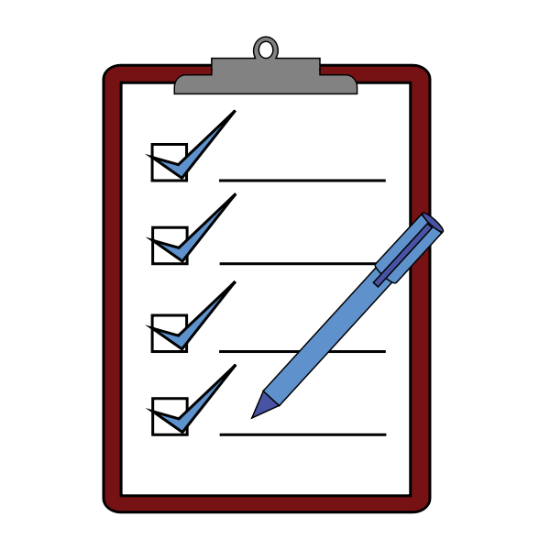
- After we have delivered Mrs. Swimmer’s meals, what do we do next?
- Tick off the delivery from the list before going to the next client.
- Tick off all of the client deliveries at the end of the delivery run.

- For our next delivery, the client has ordered 12 meals, which means the esky might be a little heavy to carry. What do you do?
- Carry the esky by yourself.
- Ask your delivery partner for help to carry the esky.

- You only have a few meals left in your eskies, should you?
a) Place all the remaining meals into the one esky.
b) Leave them and keep the meals separated.

- When we go to deliver to our next client, the door is locked and no one answers. What should we do?
a) Call the Meals on Wheels Service right away for advice.
b) Try to break into the house and help then.
c) Carry on with the delivery run.

- We need to deliver a hot meal to a client, but it has been about two hours since we left the Meals on Wheels kitchen. Should we deliver this now?
- Yes. Let’s go and finish the run. It is close enough to the two hours mark for it to be safe to deliver.
- No. it hasn’t been delivered in time. We should notify Meals on Wheels and take it back to the kitchen.

Quiz Answers
- B - The food we deliver needs to be packaged properly. If there is a spill or leak, there is a chance dirt of bacteria could get into the food and that could cause contamination! Letting the kitchen know of any incorrect packaging means the meal can be replaced and the client can eat a safe meal.
- C - The food we deliver needs to be packaged properly. Dust or other contaminates could get through the cracked lid and into the food. That can cause food contamination. Letting the kitchen know of any incorrect packaging is the right thing to do.
- A - The food we deliver needs to be packaged properly. Who knows what could get into the food through that hole? Letting the kitchen know of any incorrect packaging is the right thing to do.
- Hot: Hot beef stew and hot roast & veg Cold: Ham & salad, sandwiches and quiche & salad Frozen: frozen lasagna – It is important that food is kept at the right temperature to ensure bacteria doesn’t grow.
- B - Our clients are vulnerable to illness and disease, so you need to stay away if you’re ill. If you’re feeling unwell before a shift, let Meals on Wheels know immediately so a replacement for your shift can be organised.
- A - Cleaning your hands properly helps prevent food contamination. To do this, follow these steps:

B - It’s important that we always double check to make sure we deliver the meals the clients ordered
- A – After every delivery you make, you need to tick off the delivery from the list. This allows us to make sure the food has been delivered to the client.
- B - If an esky is heavy, two people must carry it. This will reduce the chance of hurting yourself! Remember, always bend your knees and keep your back straight when lifting.
- B - They should remain in the correct temperature esky.
- A - You should call an ambulance right away if the client is in distress
- B - We should contact Meals on Wheels so they can organise an alternative and head back to return this meal to the kitchen. We need to be careful with delivery times; all hot meals must be delivered within two hours of leaving the kitchen.

Acknowledgment of Food Transport Training Completion

I herby declare that I have completed the Food Transport
Training Workbook and understand the information outlined.

Date ...................................................

Signature .........................................................

Supervisor ......................................................

Signature ........................................................

