

Basic Knife Skills Training
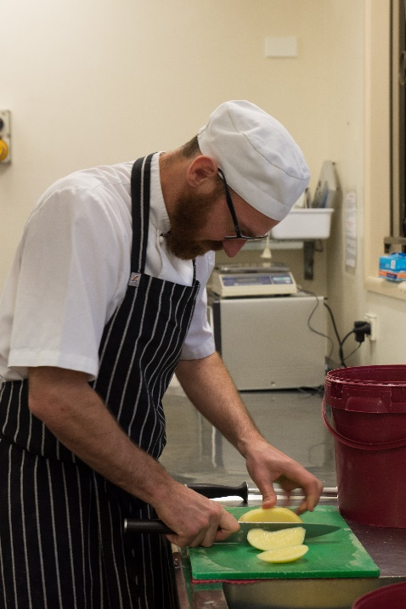

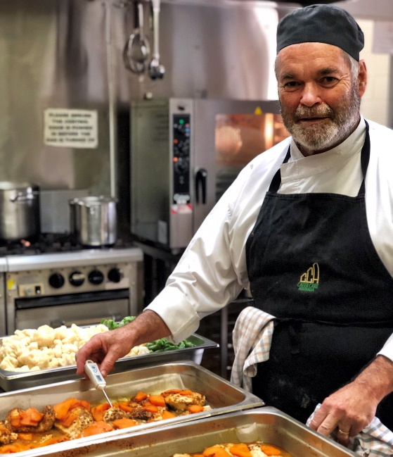
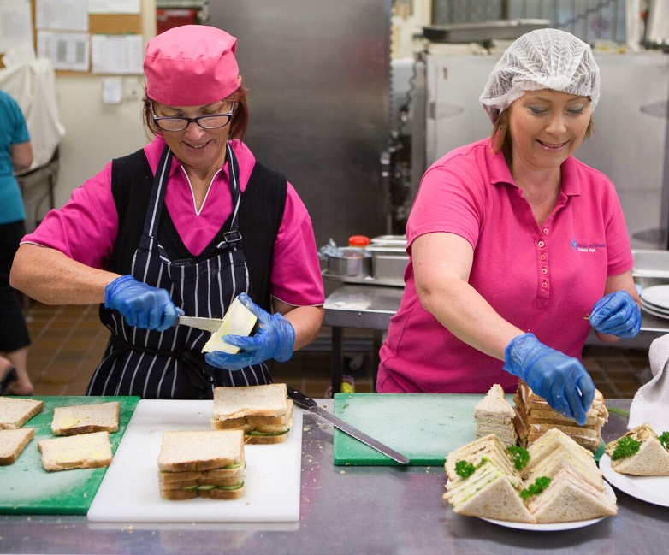

Based on the Meals on Wheels Allara Learning Basic Knife Skills Module

Introduction
Thank you for choosing to volunteer with Meals on Wheels! We love welcoming volunteers to the Meals on Wheels family and we hope that you enjoy helping us to make a difference in the community.

Before you start assisting in the kitchen, there are a few key things you need to know. This includes knowing the basics of knife safety to protect yourself and those around you in the kitchen.

Following these processes and your Service’s instructions will help you, others and our clients to stay safe. Enjoy your role in the Meals on Wheels family!

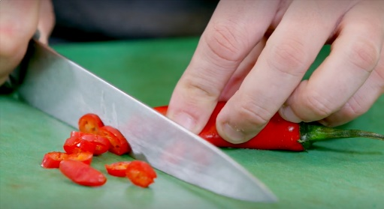

Basic Knife Skills
When using a knife to prepare meals for Meals on Wheels, some vital skills to learn include sharpening, holding the knife and slicing.
Knife sharpening should be done regularly because the sharper the knife, the easier it is to cut the food item. Using a sharp knife helps food stay fresher for longer because the food is cut cleanly rather than crushed. A sharp knife is also safer to use because it requires less force to cut food, meaning the knife is less likely to slip and cause injury.
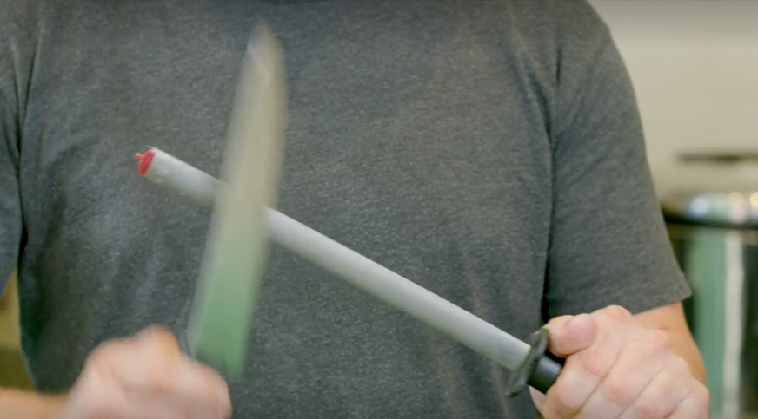
To sharpen a knife, hold the knife and steel on a 45⁰ angle to each other. Hold the knife heel against the steel on a 30⁰ angle and drag down the steel to the tip of the knife.
Repeat this action on the back of the steel to sharpen the other side of the blade. Slowly alternate on each side about 10 times. Wipe the knife clean to remove the metal dust that comes off during the process.
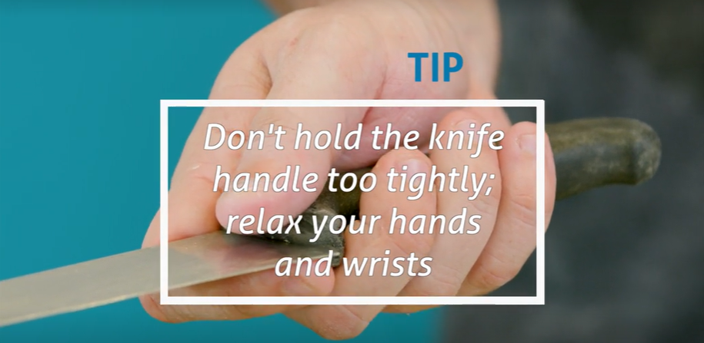
The best way to ensure you are holding the knife correctly is to place your index finger at the heel of the blade and wrap your hand around the handle. This makes the knife stable and agile in your hand.

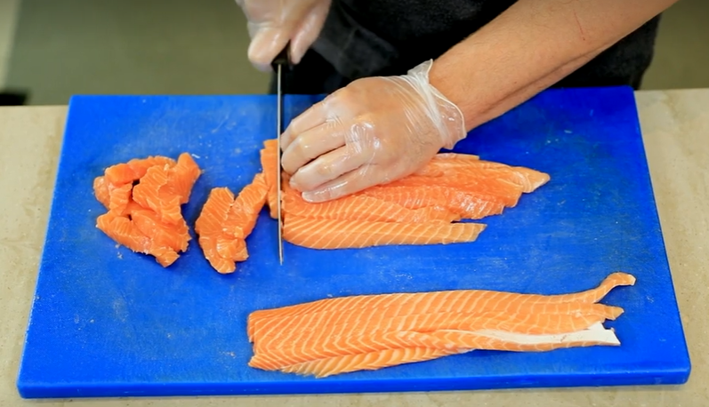
When slicing most items, use a slicing motion, dragging the whole blade across the item. This is the easiest and most efficient way to make a cut.
When using a knife always:
- Be careful and look at what you are doing;
- Wash and dry the knife by hand immediately after use and place it back in the knife rack.
When using a knife never:
- Look away to speak to someone;
- Use a knife in a way it isn’t intended, e.g. opening a can;
- Leave a knife in a sink or in the wash up area.

Acknowledgment of Basic Knife Skills Training Completion

I herby declare that I have completed the Basic Knife Skills and understand the information outlined.

Date ...................................................

Signature .........................................................

Supervisor ......................................................

Signature ........................................................

